**LAB NO 10**



**Fall 2024**

**CSE-304L Computer Organization and Architecture Lab**

Submitted by:

Name : **Hassan Zaib Jadoon**

Reg no**. : 22PWCSE2144**

ClassSection **: A**

Signature: ____________

Submitted to:

**Dr. Amaad Khalil**

**Department of Computer Systems Engineering**

**University of Engineering and Technology, Peshawar**

# **MULTIPLEXER**

**TASK 01:**

**Write a Verilog code for 2x1 Mux using Dataflow Level modeling.**

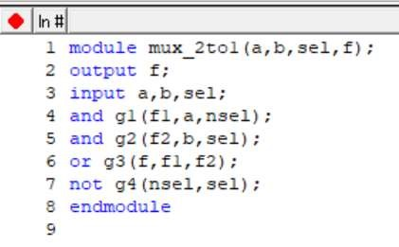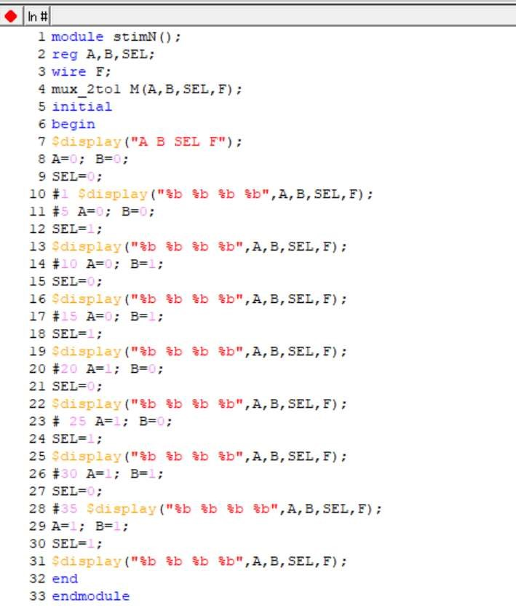

**Output:**

**Task 02:**

**Write a Verilog code for 4x1 Mux using Dataflow Level modeling.**

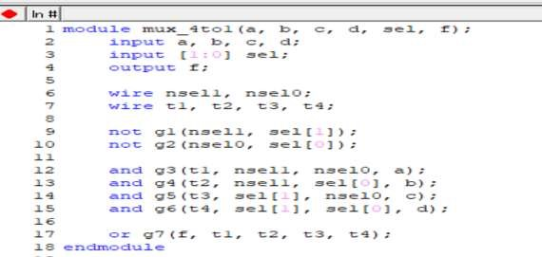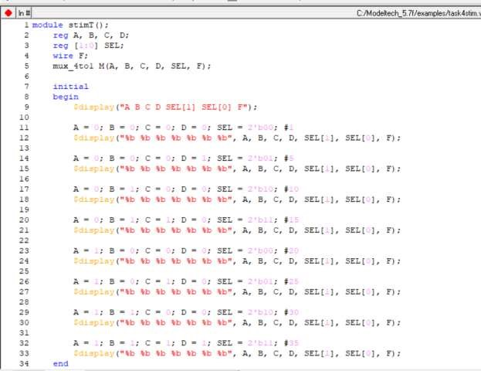

**Output:**

**Table:**

**Logical diagram:**

**Task3:**

**Write a Verilog code for 8x1 Mux using Dataflow Level modeling.**

**Output:**

**Table:**

